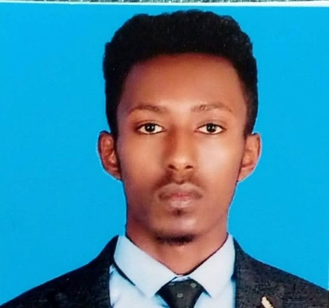
SUMMARY

Motivated and dynamic Web Developer with a keen focus and experience in web application development and web layout design, with a strong work ethic and innate ability to adapt in ever-changing and challenging environments. Education and experience in comprehensive problem solving, creative troubleshooting, and complex project management. Accomplished with effective collaboration skills, team building capabilities and leadership in diverse and multifaceted operations.

FIRDBET


+251-977-0999-88
awoke.fird@gmail.com
Gondar, Ethiopia

Personal Projects


- Built Netflix-Clone using The Movies Database (TMDB), Firebase and React JS.
- Built Amazon-Clone using Node JS, Firebase (Authentication, Firestore) and React JS.
- Built Apple-Website-Clone using React JS, Rest API in different Websites.
- Built Tesla-Website-Clone using React JS and Firebase
- Built tinDog website using Html, Css and Bootstrap

SKILLS

- HTML
- CSS
- BOOTSTRAP
- JAVASCRIPT
- DOM
- JQUERY
- WORDPRESS
- GITHUB
- MySQL
- MONGO DB
- NODE JS
- EXPRESS
- REACT JS

LANGUAGES
- ENGLISH
- AMHARIC

Core Competencies
Creative Problem Solving | Communications | Business Operations | Quality Assurance | Project Management | Enterprise Web Application Development

Education
Bachelor of Science | Mechanical Engineer | University Of Gondar
Full Stack Web Development Bootcamp Courses | EVANGADI TECH
Web Development Courses (front/back end development/self-taught) | UDEMY, COURSERA ORG.

